Chapter-
Abdul in the garden
- Mention the functions of roots.
Ans:

2.Roots are mainly two types – tap root and fibrous root. Mention the difference between them with examples.
Ans:
Tap root | Fibrous root
a.These roots penetrate deep inside the soil. | a.These roots are shallow and do not penetrate deep inside the soil.
b. They have long main root. | b. They do not contain main root.
c. Provides strong anchorage. | c. Provides moderate anchorage.
Ex- carrot, beetroot, radish etc. | Ex- rice, wheat ,grass etc.
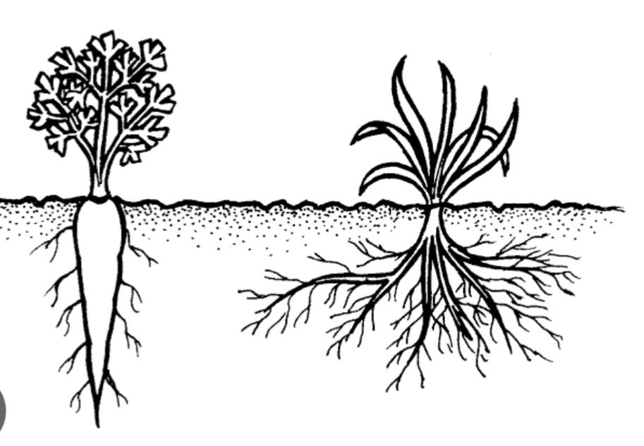
3.In a crop field there are many unwanted plants growing along with crop plants.
(i) What are they called?
(ii) Give two examples.
Ans:

4. Explain the process of weeding .
Ans: The process of removing unwanted plants , called weeds from ,a garden or a crop field so that plants that you want to grow have enough space ,water ,sunlight and food to grow properly.

5. The big neem tree or mango tree doesn’t easily get uprooted during a heavy rainfall or storm . Give reason.
Ans: The big neem tree or mango tree doesn’t easily get uprooted because of their extensive ,deep taproot system that anchor them firmly in the soil.
6.

